Case Study

**Solving Performance Pain Points**

**Client: Market Leader in Mobility Solutions**

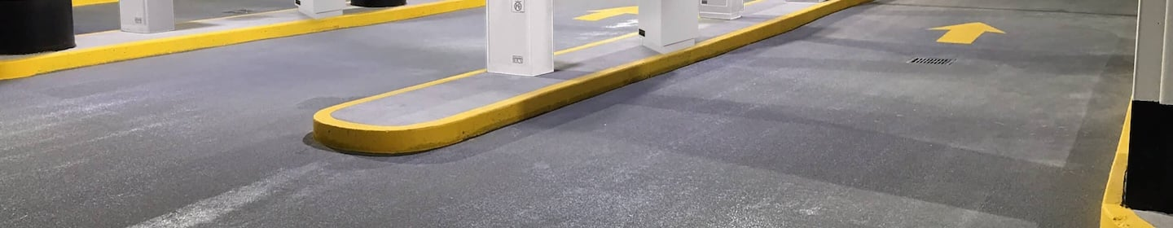

Callibrity’s proven ability to [solve complex problems](https://www.callibrity.com/services/product-consulting?hsLang=en) by [creating innovative solutions](https://www.callibrity.com/services/software-development?hsLang=en) was rewarded after delighting this mobility solution client on a previous engagement. Entrusted with diving into overall system issues, a team was tasked with a greenfield, cloud-native program. The product Callibrity built to replace legacy versions not only leap-frogged the competition but is now a showcase solution.

* Real-Time Device Monitoring
* User Management Portal
* Data Visualization



**Challenge**

A Mobility Solutions Provider known for the ease and simplicity of pay-on-entry facilities was suddenly facing big issues with legacy machines and the inability to get software and features deployed in a timely manner. A fragmented system with locations across the US that was relying on multiple versions of hardware contributed to the challenge.

**Solution**

Callibrity introduced iterative delivery in our greenfield application development to examine the legacy issues and determine the best technology solve. Consolidation was key. By writing the client a new on-site tool that would receive updates automatically, the burden of manual processes and physically interacting with machines was reduced. The new platform is cloud-native and deployed on AWS.



**Outcome**

With the modernization Callibrity delivered, production issues that formerly took months to resolve can be addressed and solved in a matter of hours. Many automated processes, such as continuous integration, and deployment on the DevOps platform were implemented so that when a developer checks in code, it is now built, tested, and deployed. Now the facility devices in the field get updated without anyone having to physically touch anything. As a result of Callibrity’s holistic approach, flexibility, and business value, we are now solving more challenges for the client.